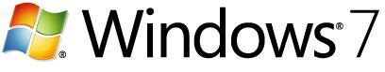

Automated Installation to Upgrade to Windows 7: Step-by-Step Guide
Microsoft Windows Family of Operating Systems
Microsoft Corporation
Published: September 2009
Abstract
This guide describes how to use the Microsoft Deployment Toolkit 2010 to automate Windows 7 installation from the image that Microsoft ships on retail or volume license media, including automatically installing applications, device drivers, and updates after installation.

Copyright information
The information contained in this document represents the current view of Microsoft Corp. on the issues discussed as of the date of publication. Because Microsoft must respond to changing market conditions, this document should not be interpreted to be a commitment on the part of Microsoft, and Microsoft cannot guarantee the accuracy of any information presented. This document is for informational purposes only. MICROSOFT MAKES NO WARRANTIES, EXPRESS OR IMPLIED, IN THIS DOCUMENT.
Microsoft may have patents or pending patent applications, trademarks, copyrights, or other intellectual property rights covering subject matter in this document. The furnishing of this document does not provide the reader any license to the patents, trademarks, copyrights, or other intellectual property rights except as expressly provided in any written license agreement from Microsoft.
Microsoft does not make any representation or warranty regarding specifications in this document or any product or item developed based on this document. Microsoft disclaims all express and implied warranties, including but not limited to the implied warranties or merchantability, fitness for a particular purpose, and freedom from infringement. Without limiting the generality of the foregoing, Microsoft does not make any warranty of any kind that any item developed based on these specifications, or any portion of a specification, will not infringe any copyright, patent, trade secret, or other intellectual property right of any person or entity in any country. It is your responsibility to seek licenses for such intellectual property rights where appropriate. Microsoft shall not be liable for any damages arising out of or in connection with the use of these specifications, including liability for lost profit, business interruption, or any other damages whatsoever. Some states do not allow the exclusion or limitation of liability or consequential or incidental damages; the above limitation may not apply to you.
© 2009 Microsoft Corp. All rights reserved.

Contents
Automated Installation to Upgrade to Windows 7: Step-by-Step Guide 5
Install the Microsoft Deployment Toolkit 6
Create a Deployment Share for Windows 7 8
Stock the Deployment Share with Source Files 10
Create a Task Sequence to Install Windows 7 14
Create Boot Media 18
Install Windows 7 19

Automated Installation to Upgrade to Windows 7: Step-by-Step Guide



Microsoft® Deployment Toolkit (MDT) 2010 is a free Solution Accelerator from Microsoft that provides a framework for using the deployment tools in the Windows® 7 operating system and the Windows Automated Installation Kit (Windows AIK). Although MDT 2010 is an advanced tool that large organizations can use in extremely complex deployment scenarios, it also is a simple tool that can provide a high level of automation in simpler deployment scenarios. This guide describes a straight path through MDT 2010 that you can use to automate the installation of Windows 7. As you become more comfortable with MDT 2010, you can learn more about customizing MDT 2010 by reading the documentation that comes with it.
You perform all steps in this guide on a single computer, except for the actual installation of Windows 7 from the deployment share, which is the last step in this guide. You install MDT 2010 on that single computer, and it hosts the deployment share. The requirements for the computer are low. It can be running Windows Vista® with Service Pack 1 (SP1), Windows 7, Windows Server® 2008, or Windows Server 2008 R2. It does not need to be a high-performance computer. All the computer really needs is about 10 gigabytes (GB) of free disk space and a network connection that each destination computer can reach. (The actual hard disk requirements depend on the number of operating system images and applications you add to the deployment share.) You can even install MDT 2010 on a laptop computer to take from location to location.
This guide describes how to use MDT 2010 to automate Windows 7 installation from the image that Microsoft ships on retail or volume license (VL) media, including automatically installing applications, device drivers, and updates after installation. This approach is called thin imaging, and it’s a best practice because it is easier to build and maintain over time. This guide does not describe how to build custom images that contain applications, device drivers, and updates by using MDT 2010. This is a more advanced scenario called thick imaging, which this guide does not recommend for small or medium organizations lacking a dedicated information technology (IT) staff. For more information about building custom disk images by using MDT 2010, see the documentation that comes with it.
This guide often directs you to choose between 32-bit and 64-bit software. To make this choice, you must know whether you’re running a 32-bit or a 64-bit version of Windows. Determine the version of Windows you’re using by clicking Start, right-clicking Computer, and clicking Properties. The System area indicates the type of operating system you’re using, as shown in Figure 1.
Note

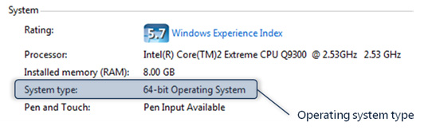

Figure 1. Determining the operating system type
Also see the following related documents:
• Upgrading to Windows 7 for Small and Midsize Businesses
• Automated Installation of Windows 7: Overview
• Manual Installation of Windows 7: Overview
- Upgrading to Windows 7 with a Standard Image: Overview
• Building a Standard Image of Windows 7: Step-by-Step Guide

For a complete view of Windows 7 resources, articles, demos, and guidance, please visit the Springboard Series for Windows 7 on the Windows Client TechCenter.
Notes
For a Web version of this document, see the Automated Installation of Windows 7: Step-by-Step Guide in the Windows 7 Technical Library (http://go.microsoft.com/fwlink/?LinkId=162744).

Install the Microsoft Deployment Toolkit
• Microsoft Deployment Toolkit 2010. There are two files, MicrosoftDeploymentToolkit_x86 for 32-bit computers and MicrosoftDeploymentToolkit_x64 for 64-bit computers.
• Windows Automated Installation Kit. Windows Automated Installation Kit. The file is called KB3AIK_EN.iso. You must burn this file to a DVD. In Windows 7 and Windows Server 2008 R2, right-click KB3AIK_EN.iso, click Open With, and then click Windows Disc Image Burner. Follow the instructions to burn the .iso file to a DVD. In earlier Windows versions, you must use third-party DVD burning software.
MDT 2010 also requires Windows PowerShell™ command-line interface:
• If you’re installing MDT 2010 on computers running Windows 7 or Windows Server 2008 R2, Windows PowerShell is already installed and you have to do nothing extra.
• If you’re installing MDT 2010 on computers running Windows Vista with SP1 or Service Pack 2 (SP2), download and install the 32-bit version or the 64-bit version from article 928439 in the Microsoft Knowledge base. Installing Windows PowerShell as an optional update from Windows Update is easier than manually downloading and installing it from the Microsoft Download Center.
• If you’re running Windows Server 2008 with SP1 or SP2, you must add the Windows PowerShell feature.
• Installing MDT 2010 on computers running Windows XP is not supported; however, MDT 2010 can refresh computers running Windows XP with a new installation of Windows 7.
To install the Windows AIK from the Windows AIK DVD
1. Insert the Windows AIK DVD into the computer, and open it in Windows Explorer.
2. Perform one of the following tasks based on the computer on which you are installing the Windows AIK:
• For a 32-bit computer, right-click wAIKX86.msi, and then click Install.
• For a 64-bit computer, right-click wAIKAMD64.msi, and then click Install.
3. Click Next.
4. On the License Agreement page, click I Agree, and then click Next.
5. On the Select Installation Folder page, click Next to install to the default installation folder for anyone who uses the computer.
6. On the Confirm Installation page, click Next to begin installation.
7. Click Close to finish installation.
To install the Microsoft Deployment Toolkit after installing the Windows AIK
1. In Windows Explorer, open the folder in which you downloaded or copied the MDT 2010 installation files. This folder contains MicrosoftDeploymentToolkit_x86.msi, MicrosoftDeploymentToolkit_x64.msi, or both files.
2. Perform one of the following tasks based on the computer on which you’re installing MDT 2010:
• For a 32-bit computer, right-click MicrosoftDeploymentToolkit_x86.msi, and then click Install.
• For a 64-bit computer, right-click MicrosoftDeploymentToolkit_x64.msi, and then click Install.
3. Click Next.
4. On the End-User License Agreement page, click I accept the terms in the License Agreement, and then click Next.
5. On the Custom Setup page, click Next to install the typical MDT 2010 features. The typical features include the MDT 2010 documentation as well as the tools and templates.
6. On the Ready to Install page, click Install to begin installation.
7. Click Finish to complete the installation.
To add the Windows PowerShell feature to Windows Server 2008
1. Click Start, click Administrative Tools, and then click Server Manager.
2. In the console tree, click Features.
3. In the details pane, click Add Features to start the Add Features Wizard.
4. In the Features list, select the Windows PowerShell check box, and then click Install.

Create a Deployment Share for Windows 7
With MDT 2010, you create and edit deployment shares by using Deployment Workbench:
• To open the Deployment Workbench, click Start, click All Programs, click Microsoft Deployment Toolkit, and then click Deployment Workbench.
• To read the MDT 2010 documentation, click Start, click All Programs, click Microsoft Deployment Toolkit, and then click Microsoft Deployment Toolkit Documentation.
Before continuing, take a moment to review the information in the Deployment Workbench (Figure 2). In the console tree, click Getting Started, Documentation, and News. These are under Information Center. Deployment Shares will be empty until you create a deployment share.

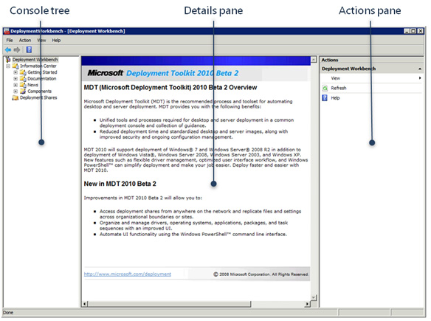

Figure 2. Deployment Workbench
Deployment shares contain all of your source files (application, operating system, device drivers, and update files). They also contain settings that customize the Windows Deployment Wizard, which is the wizard that actually installs Windows 7 on each computer, and tools that you can use to manage the deployment share. This guide shows you the most direct path through the Deployment Workbench. Until you’re more comfortable with Deployment Workbench, you can ignore settings and tools that this guide doesn’t describe. When you are more comfortable, however, see the MDT 2010 documentation to learn about the thousands of ways in which you can customize the deployment experience.
To create a new deployment share
1. In the console tree, right-click Deployment Shares, and click New Deployment Share to start the New Deployment Share Wizard.
2. On the Path page, type the path and name of the folder in which you want to create the deployment share, and click Next. The Deployment Workbench will not create the folder, so make sure it already exists, or click Browse to create it.
3. On the Share page, click Next to accept the default share name. The default share name is the name of the folder with a dollar sign ($) suffix, which hides the share from users, and this name is appropriate in most cases. If you want the share to be visible on the network, remove the dollar sign.
4. On the Descriptive Name page, click Next to accept the default name. If you plan to create multiple deployment shares, you can type a more descriptive name. Otherwise, the default name is appropriate in most cases.
5. On the Allow Image Capture page, clear the Ask if image should be captured check box, and then click Next. Using this installation method, you aren’t building custom images. Instead, you’re deploying the default Windows 7 image via the network and then customizing it after installation (thin imaging).
6. On the Allow Admin Password page, do one of the following, and then click Next:
• If you want to allow users to change the local Administrator password during installation, select the Ask user to set the local Administrator Password check box. Choose this option only if you allow users to manage the local Administrator account on their computers.
• If you don’t want to allow users to change the local Administrator password during installation, clear the Ask user to set the local Administrator Password check box. Choose this option if you want to use a standard local Administrator password for all computers in your business.
7. On the Allow Product Key page, do one of the following, and then click Next:
• If you want to allow users to specify a product key during installation, select the Ask user for a product key check box. Choose this option if you’re deploying retail media and each computer must have a unique product key.
• If you don’t want to allow users to specify a product key during installation, clear the Ask user for a product key check box. Choose this option if you’re deploying VL media and you have one product key for all of the computers in your business.
8. On the Summary page, shown in Figure 3, review the installation details, and click Next.

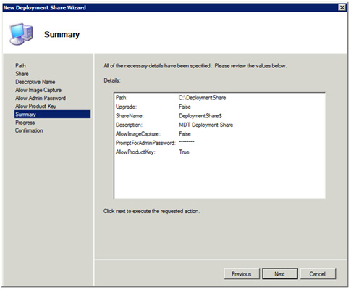

Figure 3. New Deployment Share Wizard
9. On the Confirmation page, click Finish to close the New Deployment Share Wizard.

Stock the Deployment Share with Source Files
After you create a deployment share, it contains the scripts and tools necessary to install Windows 7. It doesn’t contain the application, operating system, device driver, or update source files. In this step, you add these source files to the deployment share.
Before beginning this step, gather the files you need:
• Windows 7. You need your Windows 7 retail or VL media. You can copy the files directly from the DVD, or you can copy them from a local or network folder.
• Application source files. You need the source files for each application that you want to add to the deployment share and install during deployment. You can copy these files directly from the application’s CD or DVD or from a local or network folder. You also need the command that installs each application silently. (This guide recommends automating installation.) In most cases, software vendors document how to install their applications silently. You can also use the non-Microsoft Web site AppDeploy.com to quickly look up the silent installation command for most common applications.
• Device drivers. You need the source files for each device driver you want to add to the deployment share. You can download device drivers from each computer’s hardware vendor’s Web site. Once you download the device driver, make sure that it’s decompressed. For example, if you download a device driver as a .zip file, extract the file. If you download the file as a compressed .exe file, run the file to extract the device driver’s source files. If you can’t extract the device driver’s source files, you must install the device driver as an application.
• Updates. You’ll need the .msu files for any packages with which you want to update Windows 7. For example, you can download the Microsoft Virtual PC update and add that to the deployment share. Download updates from the Microsoft Download Center.
You can add applications to a deployment share two ways. You can copy the files into the deployment share and install the applications from there, or you can leave application source files elsewhere on the network and just add a command to the deployment share that installs them. To keep the process simple and avoid additional complexity, this guide instructs you to copy the application source files into the distribution share.
Note
To add applications to the deployment share
1. In the console tree, right-click Applications, and click New Application to start the New Application Wizard. Applications is in Deployment Shares under the deployment share you created earlier.
2. On the Application Type page, click Next to install an application and copy its source files to the deployment share.
3. On the Details page, type the application’s name in the Application Name box, and click Next. Optionally, you can also type the application’s publisher, version, and language.
4. Make sure the application’s source files are available. If you’re copying the application’s source files from a disk, insert the disk into the computer. If you’re copying the application’s source files from a network location, make sure you can access the folder containing those files.
5. On the Source page, type the path of the folder containing the application’s source files, and click Next. You can also click Browse to locate the folder.
6. On the Destination page, click Next to use the default name for the application in the deployment share. The default name is the publisher, name, and version concatenated and is the best choice in most cases.
7. On the Command Details page, type the command you want to use to install the application, and click Next. You should type a command that installs the application silently. You can use the non-Microsoft Web site AppDeploy.com to quickly look up the silent installation command for most common applications. Don’t change the Working directory box, because the default value is correct when you’re copying application source files to the deployment share.
8. On the Summary page, shown in Figure 4, review the application’s details, and click Next.

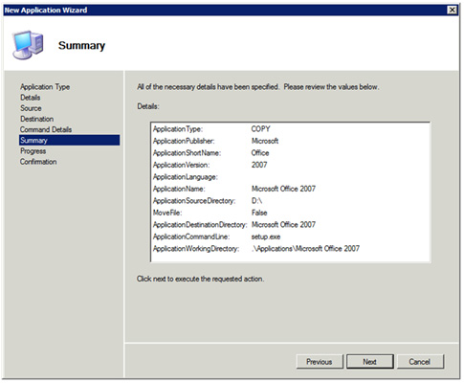

Figure 4. New Application Wizard
9. On the Confirmation page, click Finish to close the New Application Wizard.
After adding the 2007 Microsoft Office system to the deployment share, you can customize its installation. Right-click Office 2007 in the deployment share, and click Properties. On the Office Products tab, customize the 2007 Office release installation as desired by typing a product key, choosing a display level, accepting the license agreement, and so on. Click OK when you are finished.
Note
To add Windows 7 to the deployment share
1. In the console tree, right-click Operating Systems, and click Import Operating System to start the Import Operating System Wizard. Operating Systems is in Deployment Shares under the deployment share you created earlier.
2. On the OS Type page, click Next to copy the full set of Windows 7 source files to the deployment share.
3. Make sure the Windows 7 source files are available. If you’re copying the source files from a disk, insert the disk into the computer. If you’re copying the source files from a network location, make sure you can access the folder containing those files.
4. On the Source page, type the path of the folder containing the Windows 7 source files, and click Next. Alternatively, click Browse to locate the Windows 7 source files.
5. On the Destination page, click Next to use the default folder name for the deployment share. The default name is appropriate if you’re copying only one set of Windows 7 source files to the deployment share. If you’re copying multiple editions of Windows 7 (retail versus VL) to the deployment share, change the name to differentiate each edition.
6. On the Summary page, shown in Figure 5, review the operating system details, and click Next.

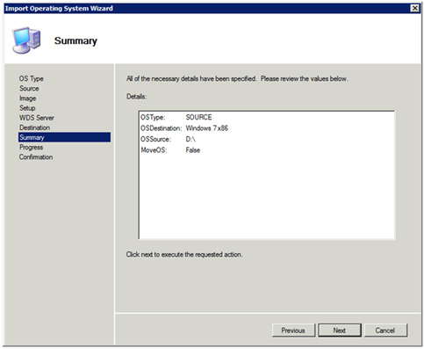

Figure 5. Import Operating System Wizard
7. On the Confirmation page, click Finish to close the Import Operating System Wizard.
To add device drivers to the deployment share
1. In the console tree, right-click Out-of-Box Drivers, and click Import Drivers to start the Import Driver Wizard. Out-of-Box Drivers is in Deployment Shares under the deployment share you created earlier.
2. Make sure the device driver source files are available. If you’re copying them from a disk, insert the disk into the computer. If you’re copying them from a network location, make sure you can access the folder containing those files. You can specify a folder containing multiple device drivers organized into subfolders, as the Import Driver Wizard imports all of the device drivers that it finds in the folder and all of is subfolders.
3. In the Specify Directory page, type the path of the folder containing the device driver source files, and click Next. You can also click Browse to locate the folder.
4. On the Summary page, review the device driver details, and click Next.
5. On the Confirmation page, click Finish to close the Import Driver Wizard.
To add updates to the deployment share
1. In the console tree, right-click Packages, and click Import OS Packages to start the Import Package Wizard. Packages is in Deployment Shares under the deployment share you created earlier.
2. Make sure the update source files are available. If you’re copying them from a disk, insert the disk into the computer. If you’re copying them from a network location, make sure you can access the folder containing those files. You can specify a folder containing multiple updates organized into subfolders. The Import Package Wizard imports all of the updates that it finds in the folder and all of its subfolders.
3. In the Specify Directory page, type the path of the folder containing the updates source files, and click Next. You can also click Browse to locate the folder.
4. On the Summary page, review the update details, and click Next.
5. On the Confirmation page, click Finish to close the Import Package Wizard.

Create a Task Sequence to Install Windows 7
By this point, you’ve created a deployment share and stocked it with application, operating system, device driver, and update source files. The next step is creating a task sequence that installs Windows 7 on computers. Think of a task sequence is a batch file or script that specifies the series of steps necessary to prepare a computer for installation, install Windows 7, and configure the computer after installation. Of course, task sequences have many more advanced capabilities that you can learn about after you’re more comfortable with MDT 2010. For now, you’ll create a basic task sequence from a template, and you won’t customize the task sequence.A critical choice that you must make when you create a new task sequence is how to activate Windows. If your business uses VL media with the Key Management Service (KMS), then you won’t specify a product key when you create a task sequence. If your business uses VL media with Multiple Activation Keys (MAKs), then you will specify a product key when you create a task sequence. Last, if your business uses retail media, then you’ll specify a product key when you install Windows 7 on each computer, and each computer must use a unique product key. If you don’t know which of these three scenarios applies to your business, contact the person in your organization responsible for licensing Windows 7 from Microsoft. For more information about Volume Activation, see Windows Volume Activation.
To create a task sequence for Windows 7
1. In the console tree, right-click Task Sequences, and click New Task Sequence to start the New Task Sequence Wizard. Task Sequences is in Deployment Shares under the deployment share you created earlier.
2. On the General Settings page, shown in Figure 6, type a unique ID and a name for the task sequence, and then click Next. The ID should be short and end with an index number. MDT 2010 uses the ID to identify the task sequence. The name should be descriptive, reflecting what the task sequence installs. For example, a good ID for a task sequence that installs Windows 7 is simply WIN7-01, and a good name for this task sequence is Windows 7 Professional. Optionally, type a description in the Task sequence comments box, which can provide more details about the task sequence and what it does.

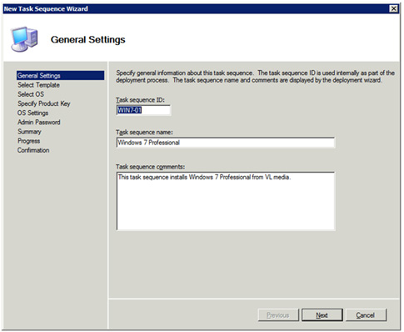

Figure 6. General Settings page of the New Task Sequence Wizard
3. On the Select Template page, click Next to use the Standard Client Task Sequence template. This is a predefined template that is already configured to properly install Windows 7.
4. On the Select OS page, click the operating system edition that you want to install by using the task sequence, and click Next. Windows 7 media usually contains multiple editions in each image file. Choose the edition that you purchased and that matches your product key. In most cases, you’ll choose either Windows 7 Professional or Windows 7 Enterprise.
5. On the Specify Product Key page, shown in Figure 7, do one of the following, and then click Next:
• If your company uses the KMS, click Do not specify a product key at this time.
• If your company has VL media with MAKs, click Specify a multiple activation key (MAK key) for activating this operating system, and type the product key in the MAK Product Key box.
• If your company is deploying retail media, and, when you created the deployment share, you chose to allow users to provide a product key during installation, click Do not specify a product key at this time.

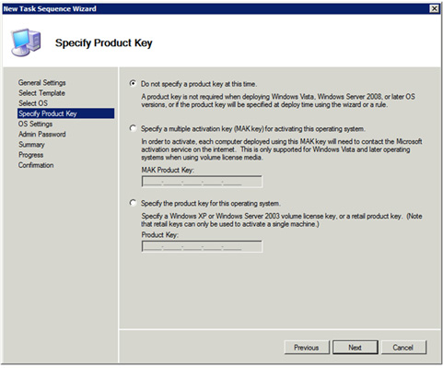

Figure 7. Specify Product Key page of the New Task Sequence Wizard
6. On the OS Settings page, type the organization name and the URL of the Windows Internet Explorer® home page that you want to configure for each user, and then click Next. You don’t need to change the Full Name box, as you’ll provide this value during installation on each computer.
7. On the Admin Password page, do one of the following, and click Next:
• If, when you created the deployment share, you chose to allow users to change the local Administrator password, click Do not specify an Administrator password at this time.
• If, when you created the deployment share, you chose not to allow users to change the local Administrator password, click Use the specific local Administrator password; then, type a local Administrator password in the Administrator Password box, and confirm the local Administrator password in the Please confirm Administrator Password box.
8. On the Summary page, shown in Figure 8, confirm the task sequence details, and click Next.

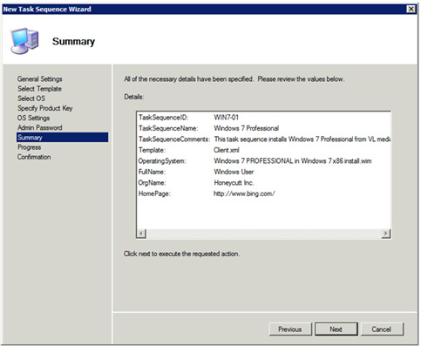

Figure 8. New Task Sequence Wizard
9. On the Confirmation page, click Finish to close the New Task Sequence Wizard.

Create Boot Media
You’re almost ready to start installing Windows 7 from the deployment share. All you need is a way to start computers that don’t have an operating system or that are getting a clean installation of Windows 7.
To start these computers, you’ll use the Deployment Workbench to create boot images. These boot images are based on the Windows Preinstallation Environment (Windows PE), and the Deployment Workbench customizes the images to automatically connect to the deployment share and start the Windows Deployment Wizard. You’ll burn these boot images to a CD and optionally copy the boot image from the CD to a bootable USB flash disk (UFD). Starting computers with a bootable UFD is much faster than starting them from a CD.
The boot images that the Deployment Workbench creates are in the Boot folder of the deployment share. The file LiteTouchPE_x86.iso is for 32-bit computers and the file LiteTouchPE_x64.iso is for 64-bit computers. Windows 7 and Windows Server 2008 R2 can burn these images to CD without using third-party software. With earlier Windows versions, you must use third-party CD-burning software.
To create boot images for the deployment share
1. In the console tree, right-click the deployment share that you created earlier, and click Update Deployment Share to start the Update Deployment Share Wizard.
2. On the Options page, click Next.
3. On the Summary page, review the details, and click Next to create the deployment share and build the boot images. This process can take from several minutes to an hour, depending on the computer’s performance.
4. On the Confirmation page, click Finish to close the Update Deployment Point Wizard.
To burn boot images to a CD in Windows 7 or Windows Server 2008 R2
1. In Windows Explorer, open the Boot folder in the deployment share. This folder contains the boot images LiteTouchPE_x86.iso and LiteTouchPE_x64.iso. If you created the deployment share in the default location, open C:\DeploymentShare\Boot in Windows Explorer.
2. Do one or both of the following:
• To burn a CD that starts 32-bit computers, right-click LiteTouchPE_x86.iso, click Open With, and then click Windows Disc Image Burner. Follow the instructions to burn the .iso file to a CD.
• To burn a CD that starts 64-bit computers, right-click LiteTouchPE_x64.iso, click Open With, and then click Windows Disc Image Burner. Follow the instructions to burn the .iso file to a CD.
To create a bootable UFD containing the boot image
1. Insert the boot CD that you created earlier into the computer.
2. Insert a UFD into the computer. The UFD must be at least 200 megabytes (MB).
Warning
Double-check that the UFD doesn’t contain data that you want to keep. By following these instructions, you will destroy the existing contents of the UFD.
3. Click Start, click All Programs, and then click Microsoft Windows AIK.
4. Right-click Deployment Tools Command Prompt, and then click Run as administrator.
5. Click Yes to open the Deployment Tools Command Prompt window with elevated permissions.
6. In the Deployment Tools Command Prompt window, type diskpart, and then press ENTER.
7. Perform the following tasks to prepare the UFD to start computers:
• Type list disk, and then press ENTER.
• From the list of disks, identify the number of the UFD. It is important that you identify the correct disk, as you will be formatting the disk. Make sure the size and free space match what you expect for the UFD.
• Type select disk number, where number is the disk number of the UFD, and then press ENTER.
• Type clean, and then press ENTER.
• Type create partition primary, and then press ENTER.
• Type select partition 1, and then press ENTER.
• Type format fs=fat32 quick, and then press ENTER.
• Type active, and then press ENTER.
• Type exit, and then press ENTER.
8. In the Deployment Tools Command Prompt window, type xcopy /s D:\ *.* E:\, where D is the drive letter of the boot CD, and E is the drive letter of the UFD. Alternatively, you can copy all the files in the boot CD to the UFD using Windows Explorer.

Install Windows 7
Now you’re ready to start installing Windows 7 on computers. You’ve created and stocked a deployment share. You’ve created a task sequence that describes the steps to install and configure Windows 7, and you’ve created boot images that can start new computers and automatically start installation.
This guide recommends two ways of installing Windows 7 from the deployment share, and this section contains instructions for both scenarios:
• New computer. To use this scenario, follow the instructions titled “To install Windows 7 on a computer by using the New Computer scenario” in this section. In this scenario, you perform a clean installation of Windows 7 by starting the computer with the boot media and running the Windows Deployment Wizard. This scenario completely removes the computer’s existing contents. It does not preserve applications or users’ data and settings. Use this scenario when you’re installing Windows 7 on a computer that doesn’t have an operating system, a computer that has an operating system that won’t start, or a computer for which you don’t want to preserve users’ data or settings.
• Refresh computer. To use this scenario, follow the instructions titled “To install Windows 7 on a computer by using the Refresh Computer scenario” in this section. In this scenario, you perform a clean installation of Windows 7 just as in the previous scenario. However, instead of starting the computer using the boot media, you start the computer using its current version of Windows, and then start the Windows Deployment Wizard from the deployment share. This scenario doesn’t preserve applications, but it does preserve users’ data and settings. Use this scenario when you want to preserve users’ existing data and settings and you’re installing Windows 7 on computers that have Windows XP with SP2 or Service Pack 3 (SP3) or Windows Vista.
To install Windows 7 on a computer by using the New Computer scenario
1. Insert the boot CD or bootable UFD into the computer.
2. Turn on the computer, and do one of the following:
• If you’re using a boot CD, press a key when prompted to press any key to boot from CD or DVD. If you don’t see this prompt and you’ve inserted the boot CD into the computer, you must enable the basic input/output system (BIOS) to boot from CD. For more information, see the computer’s documentation.
• If you’re using a bootable UFD, open the boot device list when prompted. (In most cases, pressing F12 during the BIOS splash screen opens the computer’s boot device list.) From the list of boot devices, select the bootable UFD that you inserted in step 1 to start the computer using boot media that you created earlier. If you don’t see a prompt to display a boot device list, you must enable the boot menu in the computer’s BIOS. For more information, see the computer’s documentation.
3. Click Run the Deployment Wizard to install a new Operating System.
4. In the User Credentials dialog box, type the user name, password, and domain you want to use to connect to the deployment share; then, click OK.
Tip
If you can’t connect to the deployment share, make sure that the computer can contact the deployment share. To do so, click Cancel to return to a Command Prompt window. Then, type ping computer_name, where computer_name is the name of the computer hosting the deployment share. If the ping command displays “Ping request could not find host computer_name,” a network problem is preventing the Windows Deployment Wizard from connecting to the computer hosting the deployment share. For additional troubleshooting tips, see the MDT 2010 documentation.
5. On the Select a task sequence page, shown in Figure 9, click the task sequence that you created earlier, and click Next.

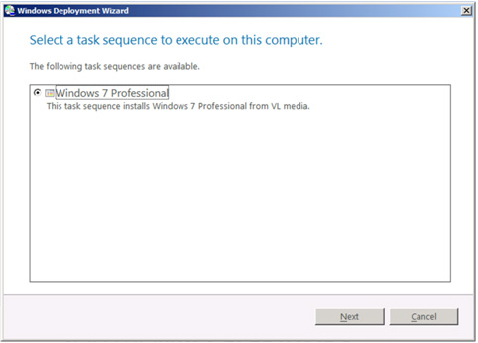

Figure 9. Select a task sequence to run on this computer
6. If, when you created the deployment share, you chose to allow the user to specify a product key during installation, do one of the following, and then click Next:
• If your company uses VL media with KMS, click No product key is required.
• If your company uses VL media with MAKs, click Activate the machine with a multiple activation key (MAK), and type the product key in the MAK activation key box.
• If your company is deploying retail media, click Use a specific product key, and type the product key in the Product key box.
7. On the Configure the computer name page, type a name for the computer, and click Next. Although you can use the suggested computer name, this guide recommends against it because the suggested name doesn’t help you identify the computer on the network. If you already have a computer naming standard in your business, name the computer according to that standard. A simple naming scheme you can use is FL-PC-NN, where F is the user’s first initial, L is the user’s last initial, and NN is a sequential number beginning with 01.
8. On the Join the computer to a domain or workgroup page, shown in Figure 10, do one of the following, and click Next:
• If your organization has a domain, click Join a domain. Then, type its name in the Domain box. Additionally, provide the credentials necessary to join the computer to the domain in the User Name, Password, and Domain boxes.
• If your organization doesn’t have a domain, click Join a workgroup. Additionally, type the name of the workgroup you want to join in the Workgroup box.

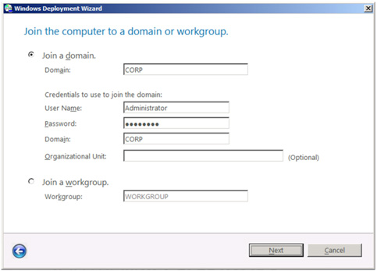

Figure 10. Join the computer to a domain or workgroup
9. On the Specify whether to restore user data page, click Next. Since this is a clean installation, you aren’t restoring users’ data or settings.
10. On the Locale Selection page, select your location from the What is your Locale list and your keyboard layout from the Keyboard list. Then, click Next.
11. On the Set the Time Zone page, click the time zone, and click Next.
12. On the Select one or more applications to install page, select the check box next to each application that you want to install on the computer, and click Next. The applications you see in this list are the applications that you previously added to the deployment share.
13. If, when you created the deployment share, you allowed users to change the local Administrator password during installation, type the local Administrator password in the Administrator Password box, confirm the password in the Please confirm Administrator Password box, and then click Next.
14. On the Ready to begin page, click Begin to start installing Windows 7. Optionally, click Details to review the installation details as shown in Figure 11.

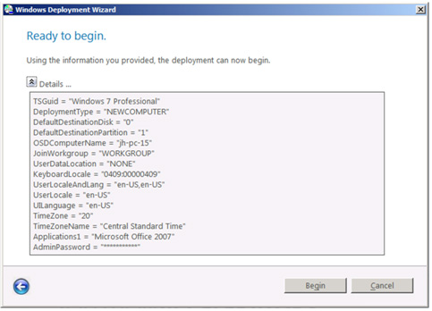

Figure 11. Ready to begin
To install Windows 7 on a computer by using the Refresh Computer scenario
1. Start the computer and log on to the previous Windows version.
2. Run LiteTouch.vbs from the Scripts folder of the deployment share. Figure 12 shows the location of this script in Windows Explorer. In this example, the computer \\win-uy45xud9ldq is hosting the deployment share, and the deployment share is named DeploymentShare$. The script LiteTouch.vbs is in the subfolder Scripts.
Note
The dollar sign ($) on the end of the share name hides the share, so you won’t see it in Windows Explorer. Therefore, you must type the full path of the share in the Windows Explorer Address bar to open it. Alternatively, you can click Start, type \\computer\DeploymentShare$, and press ENTER to open the share in Windows Explorer.

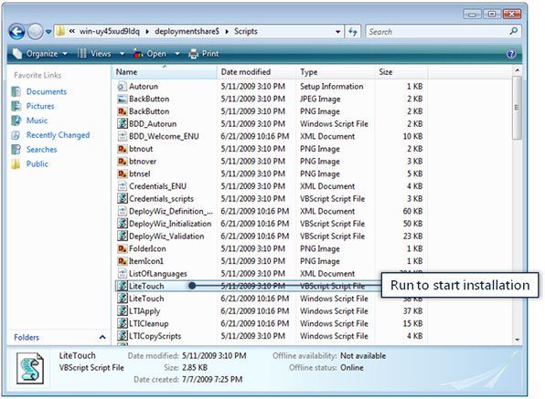

Figure 12. Location of LiteTouch.vbs in the deployment share
3. On the Select a task sequence page, click the task sequence that you created earlier, and click Next.
4. If, when you created the deployment share, you chose to allow the user to specify a product key during installation, do one of the following, and then click Next:
• If your company uses VL media with KMS, click No product key is required.
• If your company uses VL media with MAKs, click Activate the machine with a multiple activation key (MAK), and type the product key in the MAK activation key box.
• If your company is deploying retail media, click Use a specific product key, and type the product key in the Product key box.
5. On the Choose a migration type page, shown in Figure 13, click Next to refresh the computer. This guide doesn’t recommend the second option, which upgrades the previous Windows version to Windows 7 while preserving existing applications and settings.

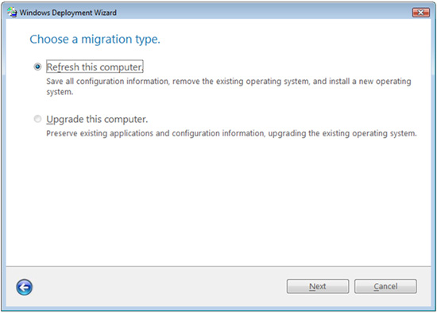

Figure 13. Choose a migration type
6. On the Configure the computer name page, optionally type a computer name in the Computer name box, and click Next. If you don’t type a computer name, the Windows Deployment Wizard reuses the computer’s current name.
7. On the Join the computer to a domain or workgroup page, do one of the following, and click Next:
• If your organization has a domain, click Join a domain. Then, type its name in the Domain box. Additionally, provide the credentials necessary to join the computer to the domain in the User Name, Password, and Domain boxes.
• If your organization doesn’t have a domain, click Join a workgroup. Type the name of the workgroup you want to join in the Workgroup box.
8. On the Specify where to save your data and settings page, shown in Figure 14, click Automatically determine the location, and click Next.

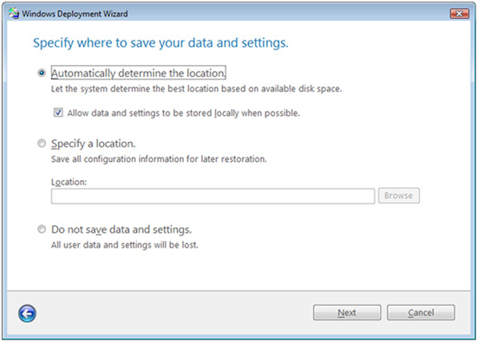

Figure 14. Specify where to save your data and settings
9. On the Specify where to save a complete computer backup page, do one of the following, and then click Next:
• To back up the computer and allow the Windows Deployment Wizard to choose the best location, click Automatically determine the location.
• To back up the computer to a specific location, click Specify a location, and type the path in the Location box.
• To prevent the Windows Deployment Wizard from backing up the computer, click Do not back up the existing computer.
10. On the Locale Selection page, select your location from the What is your Locale list and your keyboard layout from the Keyboard list. Then, click Next.
11. On the Set the Time Zone page, click the time zone, and click Next.
12. On the Select one or more applications to install page, select the check box next to each application that you want to install on the computer, and click Next. The applications you see in this list are the applications that you previously added to the deployment share.
13. If, when you created the deployment share, you allowed users to change the local Administrator password during installation, type the local Administrator password in the Administrator Password box, confirm the password in the Please confirm Administrator Password box, and then click Next.
14. On the Specify credentials for connecting to network shares page, type the user name, password, and domain you want to use to connect to the deployment share during installation; then, click Next.
15. On the Ready to begin page, click Begin to start installing Windows 7. Optionally, click Details to review the installation details as shown in Figure 15.

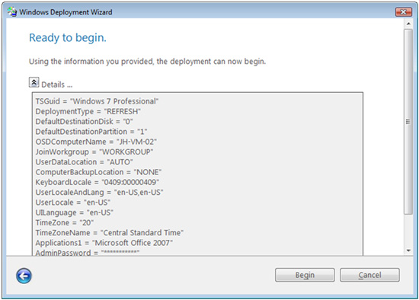

Figure 15. Ready to begin
After completing these steps, the Windows Deployment Wizard installs Windows 7 on the destination computer. Once it has finished installing Windows 7, the Windows Deployment Wizard displays an installation summary showing any error or warning messages. If the installation completed with error messages, see Microsoft Deployment Toolkit Troubleshooting Reference, which is in the MDT 2010 documentation.

