AFUDOS BIOS Update Procedure

Upon First Use of this Motherboard Series
Please insert a clean, unformatted disk into A:\ drive and boot the system into DOS mode. In DOS mode, please type in C:\> FORMAT A: /S or click on“My Computer”icon under Windows O/S, right click on drive A:\ and choose“Format”. By using the procedure above, you can create a boot disk without AUTOEXEC.BAT and CONFIG.SYS files.
Then, place the bundled M/B support CD into the optical drive. Copy AFUDOS.EXE (unzipped) onto your boot disk. Otherwise, please refer to ASUS Download Site for latest version of AFUDOS.EXE BIOS tool utility , please remember to decompress the file before copy it onto the boot disk. ASUS Download Site is located at http://support.asus.com/download/download.aspx?SLanguage=en-us
Warning：
AFUDOS.EXE (unzipped) can only be executed in DOS mode and not from MS-DOS Prompt in Windows O/S. As a result, no matter if you wish to backup or update the BIOS content, you must create a new boot disk. Please copy AFUDOS.EXE into the disk which you wish to boot the system. In addition, in the BIOS device boot sequence, you must set boot from "Floppy Drive" as the first device in the order of boot sequence.
AFUDOS BIOS Update Procedure (If neccessary)
1.Please use the prepared boot disk to boot into DOS mode. Then, type in the following commands：
afudos /i For example, afudos /ip4c800b.rom,
refers to the fullname of the BIOS file. The following shows the procedure of BIOS refreshing.
Note: Please don't switch off or reboot the system during BIOS refreshing! By doing so, you will cause serious damage to your system.
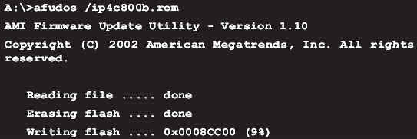
2. After BIOS refreshing is complete, the utility will return to DOS prompt (as shown in the figure below), please take out the floppy disk and reboot the system to enter the BIOS Menu.
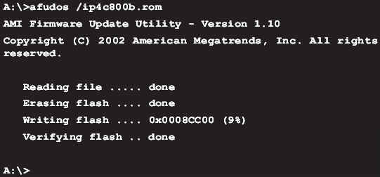
Use built-in EZ Flash BIOS to Refresh
1. Download latest ASUS BIOS from ASUS WWW and rename the BIOS filename to "xxxxx.ROM" (xxxxx represents the motherboard model you used, eg. P4C800 BIOS is named p4c800.ROM), and save the file in a floppy disk.
2. Reboot the system.
3. When the system is at POST after reboot, please hold down "Alt" + "F2" to view the following image. You may start executing EZ Flash utility. Please place the floppy disk with latest BIOS inside and insert into the floppy drive.
Note: If you have not placed any floppy disk into the floppy drive, you will see a warning message stating "Floppy not found". If the utility can not find the correct files in the floppy disk, it will show "p4c800.ROM not found!" (Assuming the motherboard is P4C800) message.
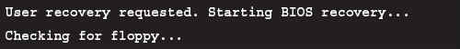
4. The system will auto-detect whether the floppy disk contains the relevant files in the floppy drive. If there is no problem, the EZ Flash utility will begin auto-refreshing and reboot the system once it is done . The procedure for refreshing is show below.
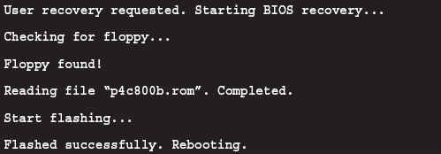
Note: Please don't turn off or reboot the system during BIOS refreshing! By doing so, you will cause serious damage to your system!

