How to iSCSI Boot Windows 2003
If you want to iSCSI Boot Windows 2003, you just need to follow the section "Quick Start" in user manual.
After v1.8, we provide a client installation program - CCBootClient. It includes sanbootconf install, ccache driver install, pnp driver install and image upload. So you just need to install CCBootClient at client and upload the image.
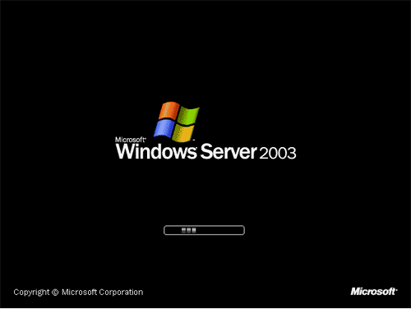

Popular Links

CCBoot - iSCSI Boot Windows Diskless
© 2000 Youngzsoft all rights reserved

