How to iSCSI Boot Windows 7 (Win7)
If you want to iSCSI Boot Windows 7, please follow the steps at below:
1. Go to the install directory of CCBoot server, you will find a file named “20G.vmdk”. Copy it to the directory that you want to save your images to. Press the “Options” button and select “DHCP Settings”, set the “IP Gateway” as CCBoot server’s IP.
2. Edit the client properties in CCBoot. Specify “20G.vmdk” as the system image for this client and then check “Keep Write-back File”. Press “Save” button to save these configurations.
3. Start the client PC and enter BIOS, set “first boot from LAN” and “second boot from CDROM”. Insert Win7 installation disk into the DVD box and then restart the client.
4. The client will boot from LAN first. It will report that “No more network devices” and then boot from DVD to install Win7. When you get to the interface where you can select the install target of Win7, you will find an iSCSI disk with 20G size. Install Win7 to this disk. If you cannot find the 20G iSCSI disk, please attach a hard disk on the PC and try it again.
5. If the Win7 installation finished, please input “iscsicpl.cpl” in the Run window to active the iSCSI service.
6. Install CCBootClient into Win7. Click the “Install CCBoot Client” on the CCBootClient interface and then shutdown Win7.
7. Go back to CCBoot server and open the client properties dialog box, press “Save to Image” button to save the image. Now you can use 20G.vmdk to boot Win7.
Notes, please test Win7 in real machine or MS Virtual PC.
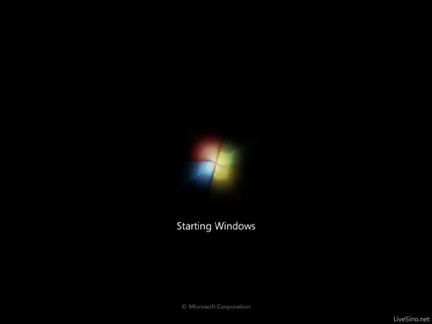

Popular Links

CCBoot - iSCSI Boot Windows Diskless
© 2000 Youngzsoft all rights reserved

